Justin Hurcombe

MSIS-2503: Fundamentals of SQL

Assignment #1

1/27/24

1. Set up environment properly
   1. Make sure SQLITE is installed and are able to run “sqlite3” to start the interactive environment.

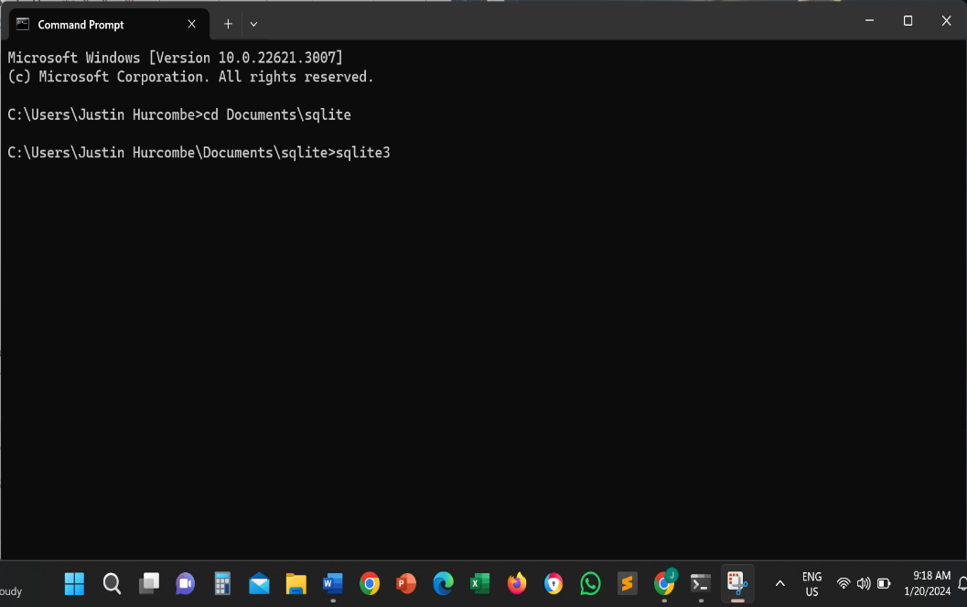

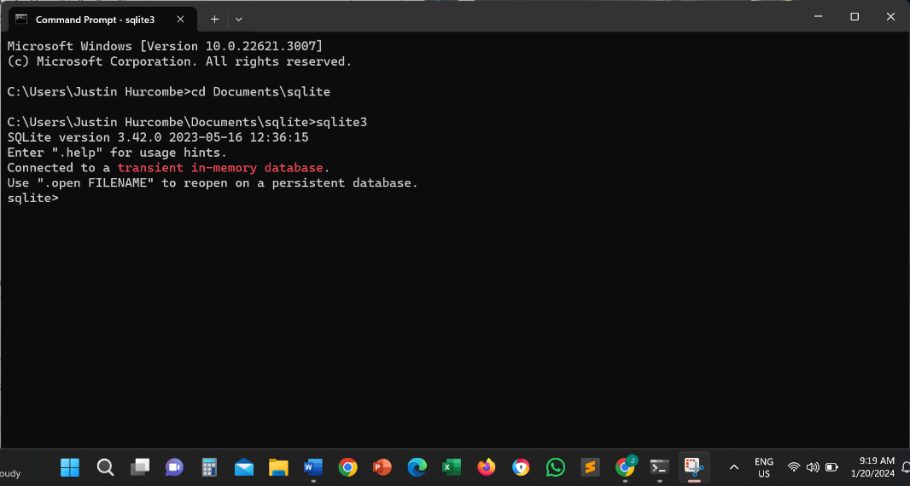

* 1. Choose your own editor

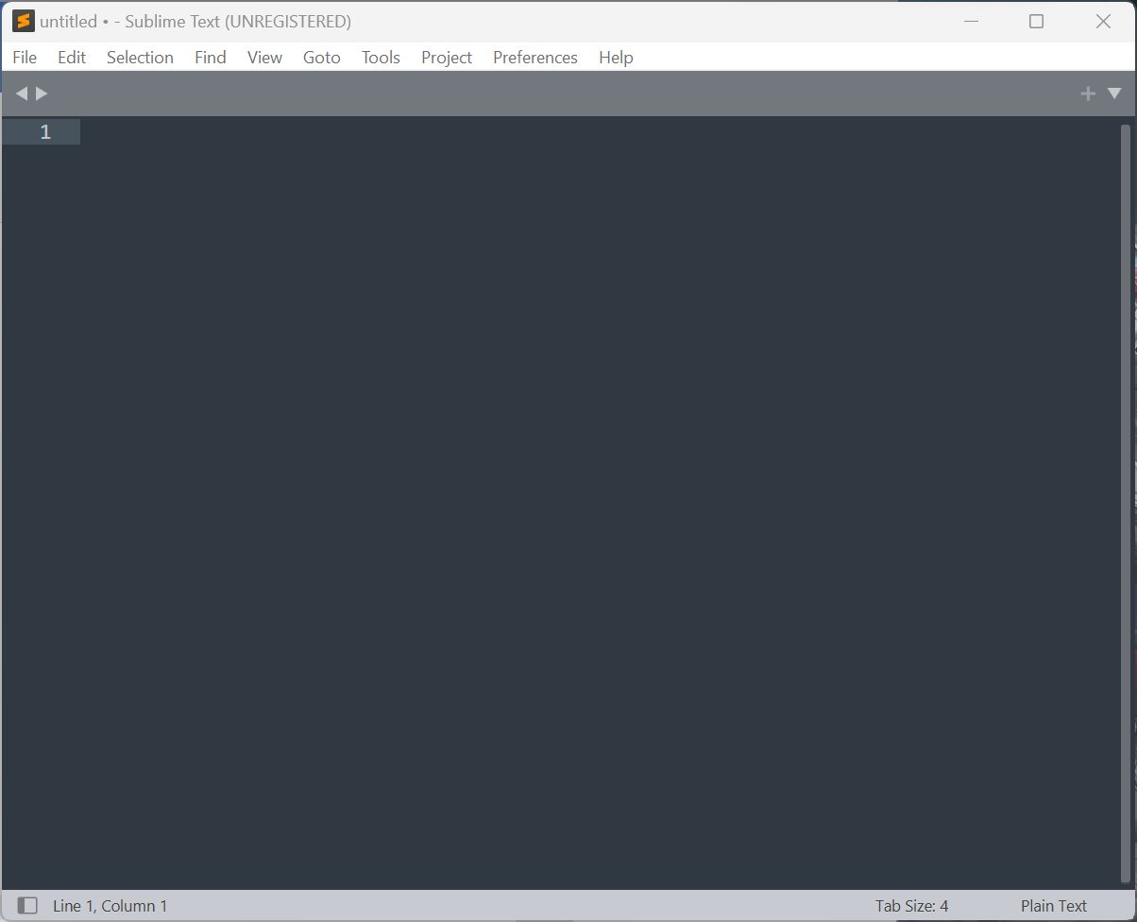

* 1. Install DB Browser

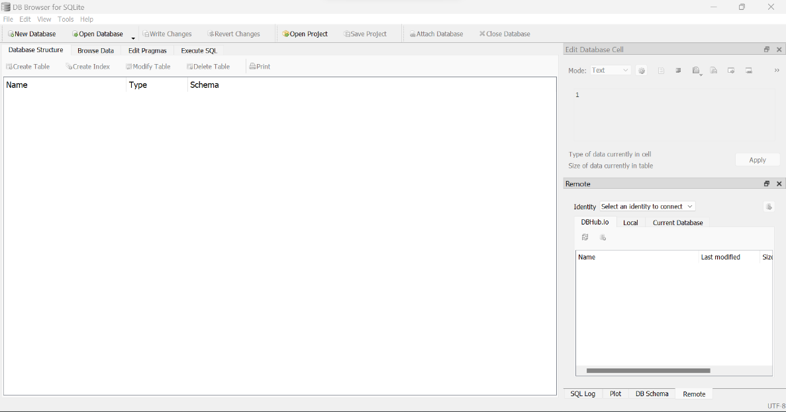

1. Use sqlite3 to create database and import CSV data into table (Name the database of your preference).

Two CSV files are provided for different city information.

In sqlite3, first use “CREATE TABLE IF NOT EXISTS” statement to create a “cities” table with two columns. Check CSV file for the name of the two columns. You decide the type of the columns.

Then follow my lecture video to import data in these two files in this “cities” table.

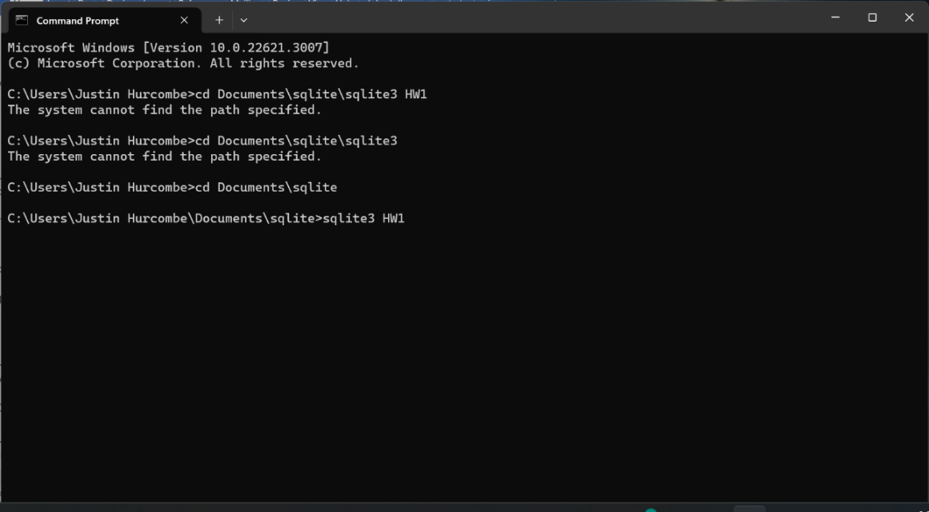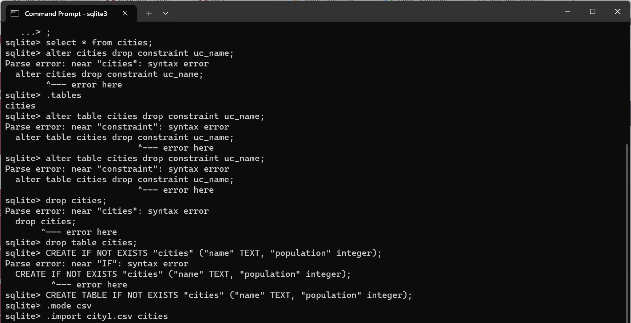

1. In sqlite3, check the table definition of this table.

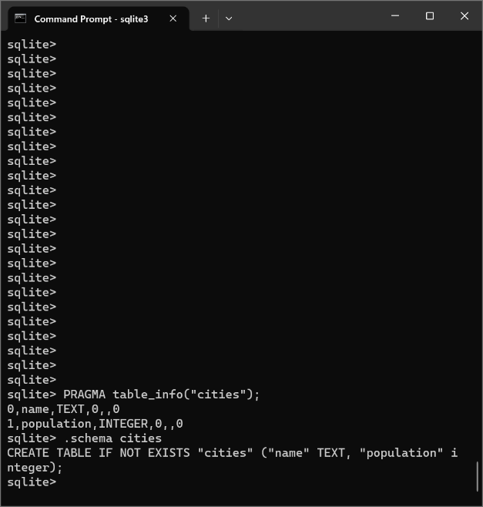

1. Use “SELECT” sql statement to check content of the table (you can specify different conditions if you know how to).

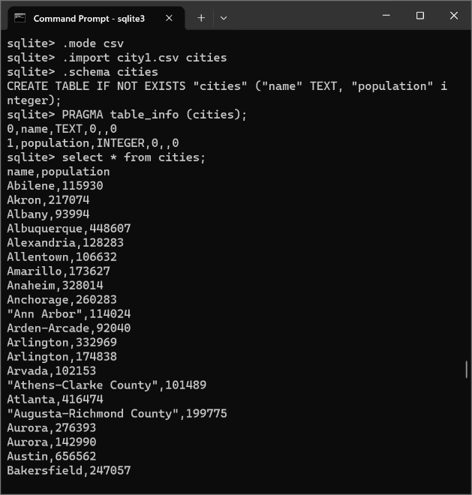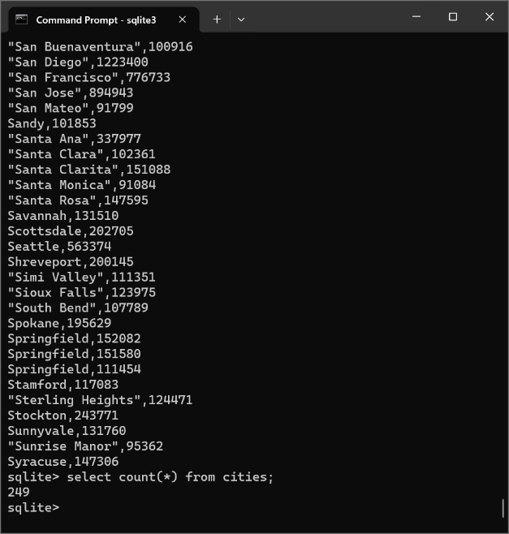

Do you see anything wrong with the data in the table?

There are several duplicates in the names field of the table (for example, Arlington appears twice), where there are several rows with the same name but different populations.

1. Use “INSERT” sql statement to insert other cities data into the table use SELECT to check your insertion result.

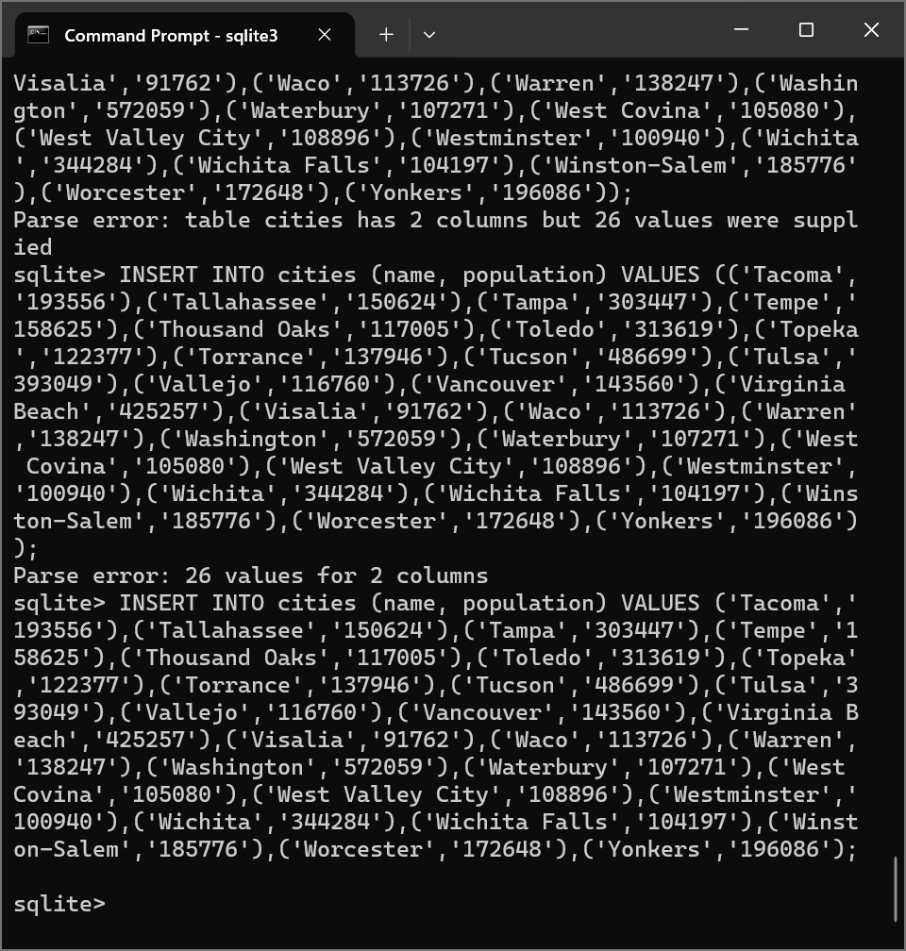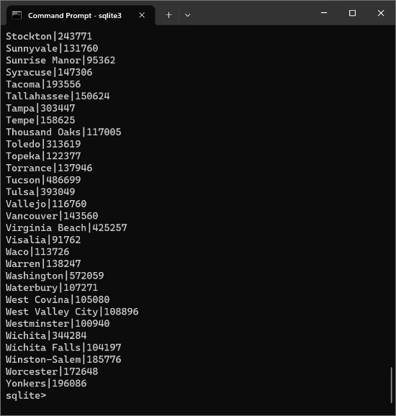

1. Use DB Browser to open your table and check out the table structure and table data.

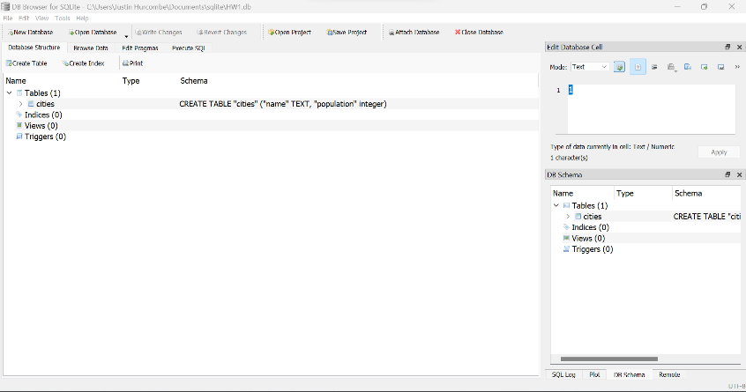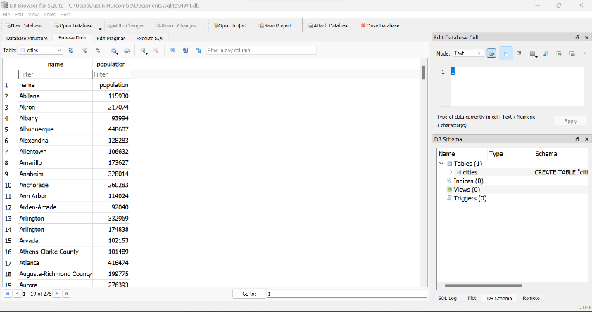

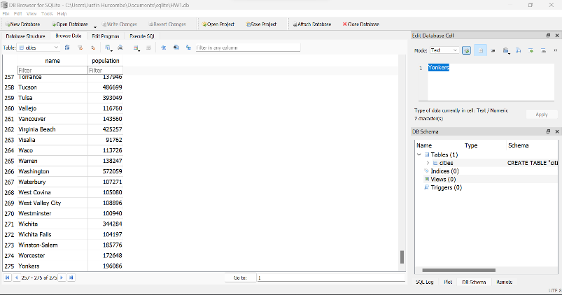

Save your screen activity (command you typed and execution result) into a file including screen shot of DB Browser image and save to PDF file. submit this PDF file.